GLASGOW MUSIC FESTIVAL
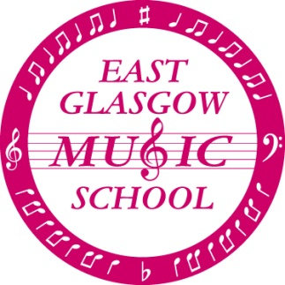

The orchestra and choirs will be performing at the Glasgow Music Festival on

Sunday 11th March 2018

The performances will take place in the Main Auditorium at The Glasgow Royal Concert Hall, Sauchiehall Street, Glasgow,G2 3NY
Choirs: 10:00am
Orchestra: 11:05am

TRANSPORT:
We will be providing buses to transport all the children from Eastbank. We will be meeting at the school at 8:50am. Please note that we will be meeting in the playground, there will be no access to the school.
I would like to encourage as many children as possible to travel to the Concert Hall on the bus as this makes it easier to keep children together when we arrive. However, parents wishing to take their children directly to the Concert Hall should ensure that they arrive no later than 9:25am. We must know in advance of your intention so that the buses don’t wait for you. Please let your child know how they will be travelling as this information will be gathered during choir/orchestra rehearsals.
Seniors who are NOT performing with the choirs may choose to travel directly to the concert hall and should arrive no later than 10.30am.
There will be plenty of staff available to supervise any members of our choirs who wish to remain and listen to the orchestra perform. However, if you wish to take your child straight from the Concert Hall following the choirs' adjudication you are welcome to do so.
Please ensure that you inform your child's group leader before leaving so that we know they are safe.
The performances should be finished at approximately 12noon and a bus will return to Eastbank at approximately 12.30pm.

DRESS:
All children must be smartly dressed in school uniform consisting of SHIRT, TIE, TROUSERS/SKIRT, SCHOOL SHOES. Jumpers /Sweatshirts must be removed while performing.
Please AVOID the following: (this list is not exhaustive!!!) trainers, brightly coloured socks/tights, elaborate hair ornaments/jewellery, etc.

WHAT TO BRING:
Orchestra: ensure you have your instrument and spare strings/reeds
Children may bring a small drink/snack and a book or QUIET toy for any waiting times. Any expensive items are brought at your own risk.

AUDIENCE
Parents and friends are very welcome to come along and watch the performances. The Music Festival will charge for entry tickets to the hall.

We look forward to an enjoyable and successful afternoon.

